Onion Architecture
https://www.youtube.com/watch?v=4EO3D6J2Xmg
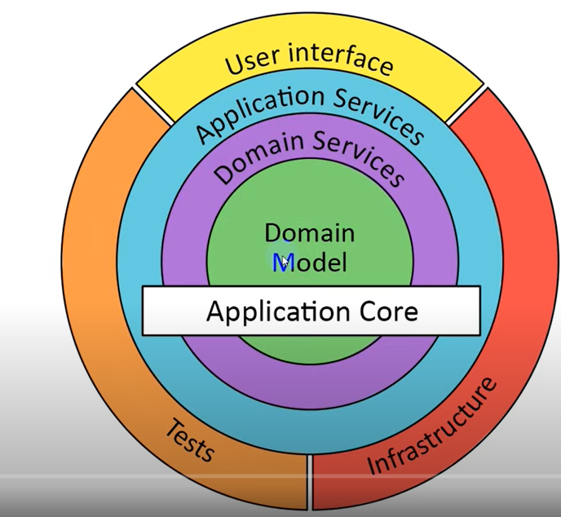

Codeopinion : https://www.youtube.com/watch?v=Ys_W6MyWOCw
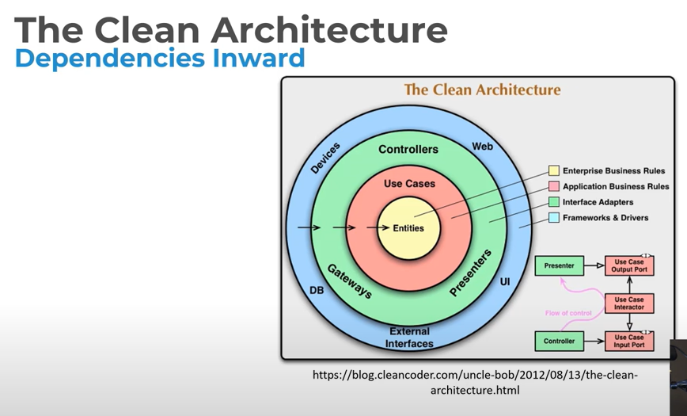
jasontaylordev/cleanarchitecture – github
